

Title CSI Linux Pocket Reference
Cover Subtitle here for this pocket reference

This is a reference that can fit in your pocket – whether printed out (if you have big pockets!) or available on your smartphone.

It’s a low-cost and low profile knowledge repository.

Margins:

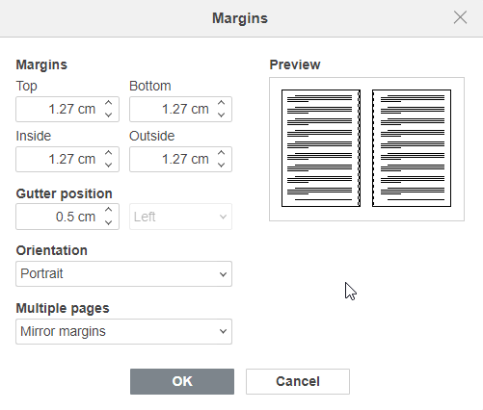

TABLE OF CONTENTS

Heading 1 - Tools 3
Heading 2 3
Heading 3 3
Here are some forensics tools 4
Autopsy 5
Description 5
FTK Imager 6
Description 6
Some More Forensics Tools 7
EnCase 8
Volatility 9
KAPE (Kroll Artifact Parser and Extractor) 10
X-Ways Forensics 11
Magnet AXIOM 12
Oxygen Forensics Detective 13
Cellebrite UFED 14
Wireshark 15

Heading 1 - Tools

This is the 6 x 9 Basic Template. Paste your manuscript into this template or simply start typing. Delete this text prior to use.

Heading 2
This is testing the Normal paragraph setting after pressing Enter from Heading 2.

Here’s the example code text:

Source Text (Lucida Console 9)

Note (Bookerly 11)

Heading 3

Heading 4

Here are some forensics tools
This is a test topic/section separator, similar to what’s used in the Red and Blue Team Field Manuals

This Topic Header style is set to be included in the Table of Contents

Autopsy

Description
Autopsy is a graphical interface built on top of the Sleuth Kit, a suite of command-line digital forensics tools. It allows investigators to examine hard drives, mobile devices, and other media by parsing files, directories, and data structures. Autopsy organizes evidence into an easily navigable format, making it possible to recover deleted files, examine metadata, and generate timeline analysis of file activity. It supports keyword searches, email parsing, and can identify system logs, artifacts, and user activity relevant to the investigation.

Table - Autopsy Basics
Command one
Command Two
Something Three

FTK Imager

Description
FTK Imager is a lightweight, user-friendly tool designed to capture forensic images of disks or memory without altering the data on the source drive. It provides a preview of files and folders to assess the importance of the data before imaging. FTK Imager can create a forensically sound copy of the data in various formats (such as raw, SMART, and E01), ensuring the integrity of evidence while verifying it with hash values like MD5 and SHA-1.

Some More Forensics Tools

EnCase

EnCase is a comprehensive forensic tool that allows users to collect, process, and analyze data from computers, mobile devices, and networked environments. EnCase scans disk sectors for hidden data, extracts files, and identifies artifacts such as logs, browser history, and email. It includes a robust case management system to organize findings and generate detailed reports. The tool ensures that evidence is preserved in a legally admissible format, supporting the entire forensic investigation lifecycle.

Volatility
Volatility focuses on memory forensics, allowing investigators to analyze volatile data from a system’s RAM. It works by parsing memory dumps (captured using tools like FTK Imager or live capture methods) to identify active processes, hidden malware, system drivers, and even remnants of terminated applications. Volatility can extract valuable information from running systems like network connections, cryptographic keys, and injected code, which often vanish upon rebooting or shutdown

KAPE (Kroll Artifact Parser and Extractor)
KAPE is a triage tool designed to quickly collect and process forensic artifacts from storage devices. It works by leveraging customizable target and module configurations to pinpoint and extract essential data such as browser history, registry entries, log files, and other system artifacts. KAPE streamlines the evidence-gathering process, focusing on speed and minimal system impact, making it ideal for time-sensitive forensic investigations.

X-Ways Forensics
X-Ways is an efficient, lightweight forensic tool designed for disk imaging, data recovery, and in-depth file system analysis. It parses file systems, examines disk structures, and reconstructs deleted or fragmented files. X-Ways is known for its low resource consumption, allowing it to handle massive data sets with minimal performance overhead. Its hex editor and powerful scripting capabilities allow investigators to dive deep into file structures, searching for hidden or encrypted data while maintaining forensic integrity.

Magnet AXIOM

Magnet AXIOM works by pulling data from computers, mobile devices, and cloud services to recover digital evidence across multiple platforms. It excels at carving out artifacts like browser history, social media activity, chat logs, and deleted files. AXIOM’s ability to visualize data, correlate it across various sources, and support deep searches through unallocated space makes it highly effective for complex investigations, especially when analyzing large datasets such as social media and cloud storage.

Oxygen Forensics Detective
Oxygen Forensics specializes in extracting data from smartphones, tablets, and IoT devices. It works by accessing device backups, app data, and cloud accounts to gather evidence like messages, contacts, media files, and location data. Oxygen’s strength lies in its ability to bypass security measures, such as screen locks or encryption, and recover hidden or deleted data. Its reporting and visualization features also help investigators piece together timelines and connections between entities.

Cellebrite UFED
ellebrite UFED is a mobile forensic tool used to extract data from a wide range of mobile devices, including locked and encrypted phones. It uses advanced methods like brute force or bootloader bypassing to access data such as call logs, messages, GPS data, and app usage. Cellebrite can also retrieve deleted files and supports forensic acquisition from social media accounts and cloud storage, making it a vital tool in mobile device investigations.

Wireshark

Wireshark captures and analyzes live network traffic by inspecting packet-level data as it flows across a network. It allows investigators to dissect network protocols, examine payloads, and identify suspicious activities like unauthorized data exfiltration or malware communication. By capturing packet data in real-time, Wireshark enables forensic experts to analyze network communications in depth, identifying patterns of attack or breaches as they occur or from log files for later investigation.



